CONFIDENTIAL

Job Application Form

PART TWO – THIS WILL BE DETACHED FROM YOUR APPLICATION FORM AND ONLY REFERRED TO FOLLOWING SHORTLISTING

DIVERSITY
We are committed to equality of opportunity for everyone. To assess whether our Diversity policy is effective we need to monitor it and to do this we need the information requested below. We can then compare the success rates of different groups at both the shortlisting and appointment stages to ensure that unfair discrimination is not taking place. This will also enable us to comply with our obligations under current legislation.

The information below will be used only for monitoring purposes and not in the selection process. Please tick correct boxes:

Gender: Male Female

Marital Status: Married Civil Partnership Single

Date of Birth: Age:

Please indicate your ethnic origin
White: Mixed: Asian
White British Mixed White/Black Caribbean Indian
White Irish Mixed White/Black African Pakistani
Any other White Mixed White/Asian Bangladeshi
Other Mixed Other Asian

Black or Black British: Other:
Black Caribbean Chinese
Black African Gypsy/Traveller
Other Black Other

Nationality ( Please State)

How would you define your sexual orientation?

Bisexual Gay Heterosexual Lesbian Prefer not to say

What is your religious belief?

Buddhist Christian Hindu Jewish Muslim Sikh

No religion Other (please specify)__________________ Prefer not to say

Disability: The Disability Discrimination Act of 1995 and subsequent Equality Act 2010 made it unlawful for employers to discriminate against their employees who are disabled and places a duty on the employer to make reasonable adjustments to enable the employee to undertake the work. The definition in the Act is "People with disabilities are individuals who have, or have had, a physical or mental impairment which has a substantial and long term effect on his or her ability to carry out normal day to day activities". If you do consider yourself to be disabled under the definition in the Act, please indicate this, even if you do not currently need any adjustments to undertake your job.
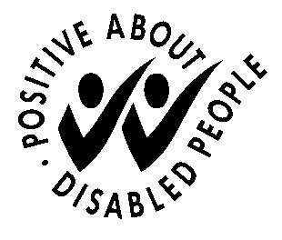

Do you consider yourself to have a disability? Yes No

